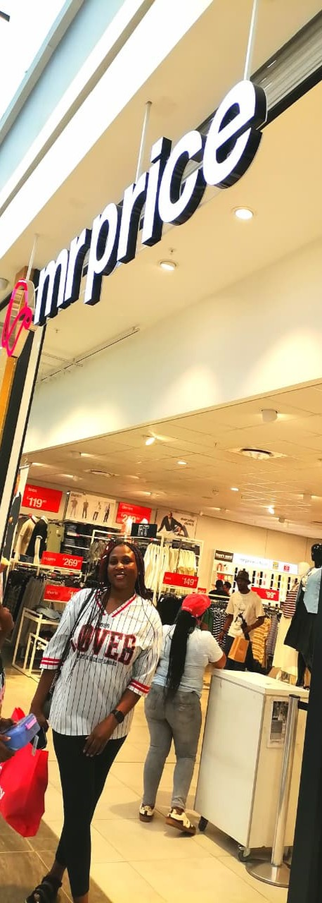
Mr Price’s Proposal
WEB DEVELOPMENT
Prosperity Chauke

TABLE OF CONTENTS
Table of Contents
TABLE OF CONTENTS 1
INTRODUCTION 2
The mission and vision statement 2
Target audience 3
Goal 3
The present key performance indicators 3
The strength and weaknesses 4
Improvements 4
The proposed website features and functionality 5
Design and user experience 5
References 7

INTRODUCTION

Mr Price it’s a retail store that is based in South Africa, its sells clothing, footwear and accessories. It’s well known for selling trendy clothing at an affordable price.
About Mr Price
- In 1985, the first Mr Price was opened in Klerksdorp, by Laurie Chiappini. From there, the store grew its product range by using organic launches. The store has grown into a group with nine divisions, serving all sorts of customers through smart expansions.
- Mr price is a store which is case-based, which provides fashion-value products to their customers. They operate in various categories such as in homeware, sportwear, financial services.
- Mr Price has 3 030 stores in total; they have 2 771 stores in South Africa.

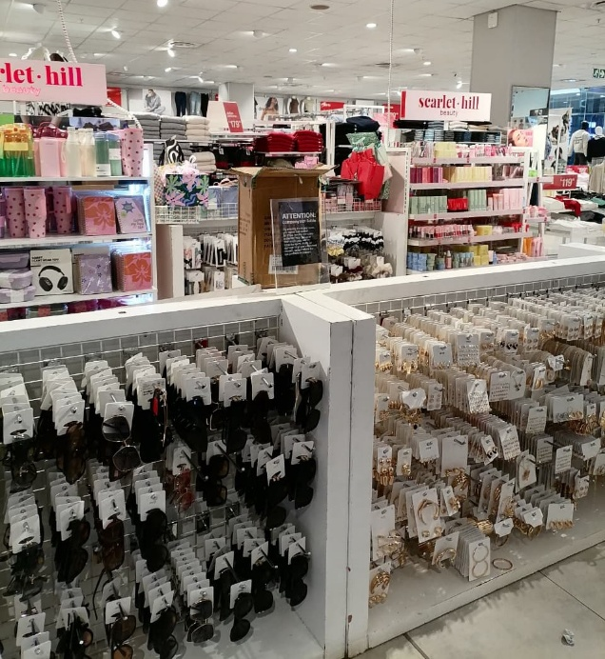
Figure 1:Accessories

The mission and vision statement
- The mission is to provide a fashion-value and quality products to their customers at an affordable price.
- The vision is to become one of the tops performing international retailer store.

Values
- Our value is to work with passion.

Objectives
- The objective is to ensure that we deliver fashionable products at an affordable price.
- We focus on tackling the youth unemployment in South Africa and try to improve the access to education.
- We focus on expanding our online retail presence by integrating shopping experiences.

Target audience
- Mr price retailer store is mainly targeting individuals who value style and fashion. It can either young or old.

Goal
- The goal is to supply fashionable products to South Africans at very affordable prices. With the help of Milady’s that opened, Mr Price helped women to feel much comfortable in their own skin.

The present key performance indicators
- Mr Price has shown a very impressive resilience when it comes to its fashion-value business model. Mr Price’s revenue has increased to 7.9% which is therefore equivalent to about R40.9 billion.
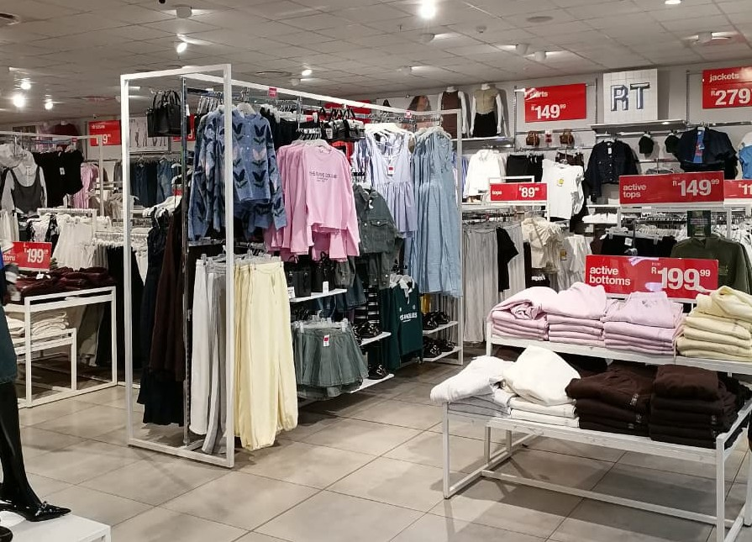

The strength and weaknesses

Mr Price strengths are:
- Mr Price has a very strong margin that sits on 41.9% gross and 11.5% for operating. This particularly means that their pricing and costs are at a very good scale.
- Mr Price must use their money very wise because they have a higher return rate of about 28.5%, which does not balance their cash spending but also make their shareholders to be happy.
The weakness of Mr price is that:
- On the other side their weakness is that Mr Price is using a lot of borrowed money, making their finances to be in a higher risk.

Improvements
Mr Price’s homewares sales are expanding every time, the customers are also paying more especially through cash, this is a great thing to Mr Price because this way they can try to strengthen when it comes to their credit offer.

The proposed website features and functionality

- The retail store had taken a new dimension when it came to their channel. They have taken a new dimension with an integrated omni-channel approach, which is a channel that enables customers to buy from literally wherever they choose whether its online, in-store or even through their mobile app.
- The store is also focusing on the sustainability initiatives, where they are working to reduce the use of single use plastic bags in its operations.

Design and user experience
- The Mr Price’s design is so clean, simple, contemporary and user-friendly. This simplicity design makes ease for use. The brand identity creates an immediate and lasting impression.
- Typography of the Mr Price website display size and colour to highlight crucial content and to guide the viewer through the content.
- The layout is clean, modern, user-friendly and easy to navigate.
- The design elements make the website to be more appealing, user-friendly and easy to navigate for customers.
- The website utilizes a clear low-fidelity centres on simplicity and usability, whereas the information hierarchy centres on the shopping categories.
I will be using html to structure my website, CSS for making my webpages to be more visual and JavaScript to add interactivity.
- Week1-week4: Decided on which organisations to work on. Did my research on that. Looked for pictures on unsplash. Creation of the root folder and sub-files
- Week5-week6: Started my proposals, gathered all on links on word. Edited them where possible. Drafting my website, doing a wireframes.
- Week 7-8: Begin with CSS, created the CSS file. Learn the tags and link the file to my html pages.
- Weeks 9-13: Submission of CSS. Begin with Javascript .
- Week 13-14: Submission of Javascript

BUDGET
- The budget for hosting website is typically R3,756 per month and maintaining the website cost about R52,600- R104,600 per year, the repairs and branding updates cost about R10,000 monthly for the physical store . So annual we spend about R120,000.

References
Comparably. Mr Price Group Mission, Vision &Values, 17 January 2026. [Online]. Available at: https://www.comparably.com/companies/mr-price-group/mission. [Accessed 01 April 2026]
EasyAssetManagement. Mr Price: A mixed bag, but Long-Term Strength Emerges,28 July 2024. [Online]. Available at: https://blogs.easyequities.co.za/mr-price-financial-performance .[Accessed 02 April 2026].
Matthew, Ramirez. Mr Price Group: Business Model, SWOT Analysis, and Competitors 2026, 06 November 2025. [Online]. Available at: https://pitchgrade.com/companies/mr-price-group [Accessed 03 April 2026].
Mr Price Group. About Us. [Online]. Available at: https://mrpricegroup.com/about-us/ [Accessed 02 April 2026].

